KAGGLE DIGIT RECOGNITION COMPETITION

Kerry Gip | Odyssey Villagomez | Yash More
University of Colorado Denver | University of Colorado Denver | University of Colorado Denver
Denver, CO | Denver, CO | Denver, CO
Kerry.gip@ucdenver.edu | Odyssey.villagomez@ucdenver.edu | Yash.more@ucdenver.edu
Individual Contributor | Individual Contributor | Individual Contributor
Support Vector Machine and K Nearest Neighbor | Convoluted Neural Networks and K-Nearest Neighbor | Artificial Neural Networks and Gradient Decent Backpropagation

Problem Statement and Background
Recognizing handwritten digits is a common deep learning problem that is useful for students to learn as an introduction into deep learning methods and evaluation ^{[1]}. In addition to academic interest, handwriting recognition can also be useful for commercial reasons such as reading bank checks and sorting postal mail. This digit recognition task is supplied and evaluated by Kaggle. The task is to scan pixel images of handwritten digits and identify them as a number between 0 – 9. The success of our digit-recognition deep learning model will be based on the accuracy of the digit predicted compared to its actual value. Current existing models have been able to achieve excellent results, with an accuracy prediction error of less than 1%. Accuracy and Root Mean Squared Error (RMSE) will be used to measure our success.
The data for this project will be provided through Kaggle. The Modified National Institute of Standards and Technology (MNIST) provides datasets for computer vision, and specifically, its handwritten dataset will be used for Kaggle’s Digit Recognition competition ^{[2]}. The test and train datasets will be used to perform different algorithmic analysis.
The data files contain grey scale images of handwritten digits. Each image is 28x28 pixels ^{[2]}. The training set has 785 columns, with the first column being “label”, the target column that will be used to train the models with. The remainder columns are the 784 pixels corresponding to each individual image.
Since this is a competition, the main goal is to achieve the highest accuracy. The motivation behind this project is to get over 99% accuracy, if not 100% accuracy.

METHODS
We have chosen to evaluate multiple models’ performance on image recognition. These models include Support Vector Machine (SVM), Convoluted Neural Networks (CNN), K-Nearest-Neighbor (KNN), and Artificial Neural Networks (ANN). Our data pipeline consisted of 8 steps: data collection, cleaning, scaling, splitting, model fitting, model training, model testing and evaluation.
The data was collected from the Kaggle website, where it is supplied by MNIST. After downloading the datasets from the Kaggle competition, the data was read into a data frame using the Pandas library. After collection, the data integrity was checked by looking for any missing values. In the case of missing values, they would be replaced with the average value of the column. Doing so would preserve the data distribution and ensure that the dataset be as symmetric as possible. There were no missing values found in the MNIST provided dataset.
After collecting and cleaning the data, we printed some of the images to the screen to get a better idea of what the data looks like.
The next step in our pipeline involved scaling the data. Data scaling is a technique to bring the data points closer together and lower the discrepancies between them. Two different scaling techniques were employed when necessary, sklearn’s StandardScaler() and normalization techniques, which normalizes the dataset between the range [0,1]. Standard Scaler was used because it scales all values between minimum and maximum values so that all values fall between that range. Since normalization was used, there was no need to use the other scaler, MinMaxScaler().
Initially the provided training set was split into an additional train and test set using test_train_split() so that we could evaluate how the model performed before running the model on the true Kaggle test set. The train set was split using a 75:25 split. After scaling, fitting and splitting the data, the data was trained and tested on each machine learning model to evaluate which model works best and which would give the highest accuracy. After the models were trained on this reduced set, they were then trained on the full train set and submitted to Kaggle
Support Vector Machine (SVM)
The objective of the support vector machine algorithm is to find a hyperplane in an N-dimensional space (N — the number of features) that distinctly classifies the data points ^{[4]}. The goal is to find a hyperplane that can find the maximum distance between data points. Maximizing the distance allows future data points to be classified with more confidence. Hyperplanes are decision boundaries that help classify data points into different classes and separates them (see figure 1). When there are 3 features, it becomes a 2D plane. The plane expands in complexity as there are more features to be classified. Support Vectors (see figure 1), are data points that are close to the hyperplane that dictates the direction of the hyperplane (I.e. How slanted the plane is, if vertical/horizontal, etc). In a 2-class example. The value to determine classes is either 1 or –1, therefore the reinforcement of the classes is dictated by [-1,1] ^{[4]}. To maximize the margin between the data points and the hyperplane, the cost function is used. The cost value will evaluate the performance of the SVM’s and will update the weights of the gradient accordingly and with each iteration, accurately determine the max distance between data points and determine the support vectors.

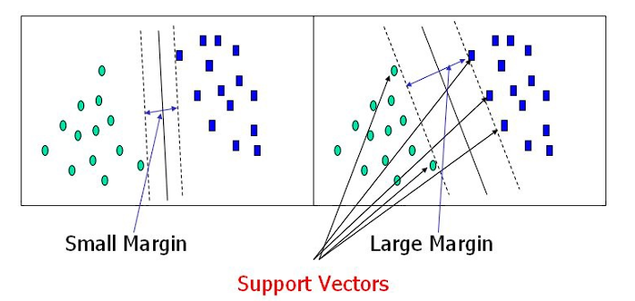
Figure 1. This diagram^{[4]} shows the blue hyperplane line separating the two sets of blue and green data points into different classes. The arrows are pointing towards the data points that would be our support vectors. They are from both of the classes and set the position of the hyperplane
Convoluted Neural Networks (CNN)
A Convolutional Neural Network is a specialized Deep Learning Model that extracts key features from the image and uses these features to classify the image from a predetermined set of classes. CNN’s are modeled after the connective patterns of the neurons of a human brain, which is where the term “neural network” comes from ^{[5]}. In this network, the image is passed through a set of Convolutional and Pooling layers where the data is transformed through an activation function and reduced using a Pooling layer. The activation functions work to reduce the size of the image to a smaller matrix, without losing important features needed for the classification ^{[5]}. The pooling layer is necessary to avoid the activation function increasing the dimensions of the data set, which can increase computation time as the data set grows. Pooling helps to make the model scale better. CNN models have been shown to work well on image classification because they can successfully capture the spatial and temporal dependencies in an image through the application of filters ^{[5]}. A filter is a matrix that shifts over the image matrix by some stride length and performs a matrix operation on the image and filter, saving the results in a new matrix. The filter is made of trainable weights whose purpose is to learn the patterns that are important to the position of the input data. The more complex the image, the more filters are needed to extract the complexity required to classify the image. The specifications of the filters and activation functions will be described further in the tools section.
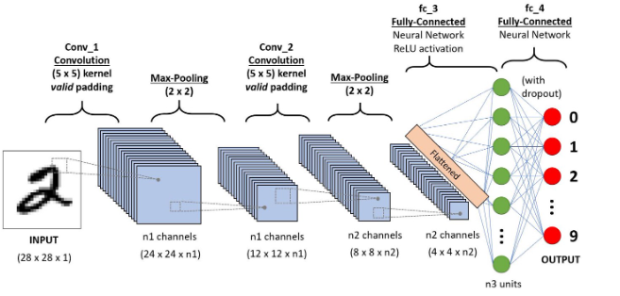
Figure 2 A CNN diagram. The original image is being fed into the convolutional layer, pooling layer, and final activation. The final output will give the predicted classification ^{[5]}.
K Nearest Neighbor (KNN)
K nearest neighbor algorithm is a data classification algorithm. It is a type of supervised machine learning used to solve classification problems, such as classifying the MNIST data set. It is called a lazy learning algorithm because it doesn’t perform any training, doesn’t perform any calculations and doesn’t build a model until a query is performed ^{[6]}. It determines what group a data point belongs to by looking at the data points around it, by classifying the nearest data point, or nearest neighbor. It is ideal for classifying data that is well defined. For example, in figure 2 below, there have two classes, red X’s and blue circles. There is a need to classify this green square into the two classes. Distance metrics, such as the Euclidean distance will help determine which class the square belongs to. Based on the distance, the green square should belong to class red X. In KNN, K is the number of nearest neighbors and is the deciding factor to how well the algorithm will perform.

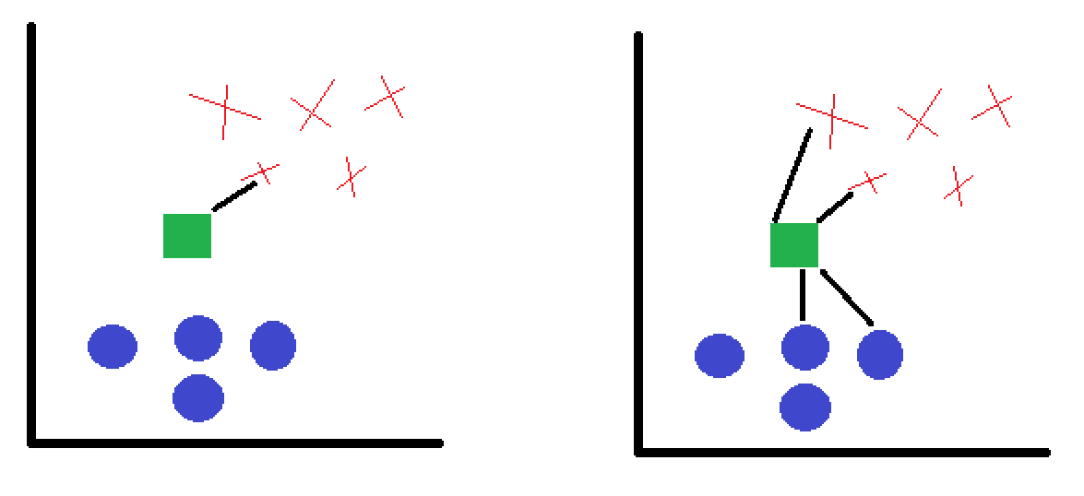
Figure 3. This diagram shows two different classes, red X’s and blue circles and a new unknown variable, green square. and a need to be able to classify a third using distance metrics where K = 1 on the lefthand side and K=4 on the righthand side.
Artificial Neural Networks (ANN)
The Artificial Neural Networks in also called the base neural networks. Just like convoluted neural networks, it is inspired by the biological neurons of the human brain. Neural networks is a computational learning system that is able to translate data from one form, into another form ^{[7]}. Referring to the image below, ANN’s consist of at least 3 layers (see Figure 3); the input layer, hidden layer and output layer. The input layer is where all of the information from outside comes in (ex. reading in data) and that data gets transferred to the hidden layer(s). The hidden layer is where all of the computations are performed. A perceptron is inside of the hidden layer and that is what specifically performs the computations of a simple neural network. For an artificial neural network, multilayer perceptron are needed. The output layer is the output or results of the hidden layer.
Inside the hidden layer, the input data is attached with weights. The inputs are attached to a perceptron and the input are multiplied by their weights, which are initialized randomly ^{[7]}. Back propagation with gradient descent is then applied and explained below.

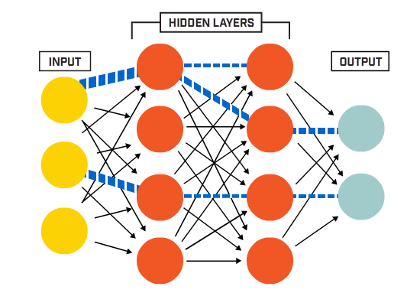
Figure 4. This diagram is the basic structure of an artificial neural network. Input is read into the input later and perceptrons calculate any sort of computations that are necessary to classify the data and then output. image reference: hidden-layers-in-network.gif (550×400) (llnwd.net)
Gradient Descent and Backpropagation
Back propagation is the process of finding the difference between actual and predicted values, optimizing the weights and updating the weights accordingly to help minimize the error ^{[7]}. The weights are updated with the use of optimizers. Gradient descent is one of them.
Gradient descent is a process to optimize the new weights. To optimize the new weights, it is used to minimize the loss function and achieve a prediction value close or exact to the actual value. The loss function describes how well a model will perform with its current weights. The lower a loss function, the better the model.
To apply gradient descent and back propagation to ANN’s, the weights are initialized randomly, and the errors are calculated within the hidden layer. The gradient is then calculated, and new weights are given. The weights are then updated continuously to achieve a new global minimum of the loss function. The equation to calculate new weights also includes a learning rate, alpha. Alpha is used to determine how large the “steps” are needed to be taken to update the weights. Too large of an alpha and to find the global minimum can be overstepped vs too small of an alpha can take a very long time.
DATA
The data will be provided by Kaggle and the MNIST Database of Handwritten Digits and has the training set of 60,000 samples and test set of 10,000 samples. It is subset of a larger set available from MNIST. These digits have been size-normalized and centered in fixed-size images.
The train dataset and test dataset are in csv format. This competition is evaluated based on the accuracy of the predictions with a higher accuracy indicating a better model. The goal of the competition is to take every handwritten image from the test set and write a program that can accurately determine what that digit is.
Different learning multiple classification algorithms to apply to this problem as well as computer vision. Since this is a competition, there is a need to improve the accuracy scores with every iteration until the competition closes. A measurable goal is to have an accuracy score of over 90% and an error rate comparable to the current existing models of less than 1%.

TOOLS
The main tool that will be used is Jupyter notebook sponsored by Anaconda. It makes running each individual contributors' work easier to separate within each section as well as include Markdown text boxes inside of Jupyter to organize the data and write the results into one cell.
GitHub will be used to track progress and changes made using its ability to manage version control.
Machine learning algorithms is the preferred method of choice to be able to determine what numbers are shown using the MNIST dataset. With such a large dataset, it is preferred to use machine learning algorithms because it easily identifies trends and patterns and can classify them quickly. As it continuously learns about different features, it can classify them as it goes based on the parameters that are placed on them, such as changing the bias, automatically adjusting the weights, manipulating the step size, etc. SVM, KNN, ANN and CNN are all supervised learning algorithms. Since all of the classifications are defined, i.e 0-9, the classifications are limited to how well they can determine those values.
The dataset will be downloaded through Kaggle where the data will be cleaned and processed. The data will be trained using multiple regression and algorithm techniques that will be applied, such as K-Nearest Neighbors, Convoluted Neural Networks, Support Vector Machine (SVM), Artificial Neural Networks and Gradient Descent Back Propagation. For Artificial Neural Network and gradient Decent using Backpropagation, the TensorFlow Virtual Environment (TF venv) within Anaconda is also used where it creates an environment with all of the compatible libraries. A short description of each of the methods is listed in the Methods Section.
In the CNN model, the initial layer was the Conv2D filter, which is commonly used to extract edges, color, and orientation in images ^{[5]}. The handwritten images have edges and orientation associated with them that will work well with this filter. Conv2D filters are computationally expensive, and we have 784 features across 42000 images so the size of filter will be kept small at 32 filters of size (3,3) ^{[8,9]}. The activation function associated with this filter was the Rectified Linear Unit (ReLu). This non-linear activation function transformed the data non-linearly after the linear filter multiplication. We need a non-linear transformation otherwise the model would just be a linear function, which doesn’t work well for 2D or 3D images. The ReLu function was chosen because the tanh and sigmoid functions map large values to 1 or small values to 0, which limits how well the model can continue to learn from the input when the values are being shifted to the same values ^{[8]}.. Finally, a final softmax activation layer was chosen to connect the outputs from the convolutional layers. The softmax function will map each image to each of the 10 classes, whose combined values will sum to one, giving us the final probability of what the handwritten image is, of which the highest probability is the chosen label ^{[10]}.
In the ANN model, the ReLu activation function was also used. We used the Sigmoid function at the end for the final classification to convert the model’s output into a probability score, which is easier to work with and predict. It is also called the Squashing function. Its domain functions as a set of all real numbers and its range are (0, 1). Thus, if the output number is either an exceptionally large number or a negative number it is always put between 0 and 1. We also used categorical cross entropy as the loss function. The reason behind using categorical cross entropy is that it is a multi-class classification task. That is, it is well suited to classify the task, it works on the fact that the one example can only belong to one class with a probability of 1 and to other categories with a probability of 0. We had a learning rate of 0.01, for this model, as the learning rate regulates the weights of our neural network concerning the loss in gradient and thus controlling the hyperparameters. After weighted inputs are passed through, it guarantees the output to either be a 0 or 1. It is a nonlinear separation line between the values.
All of this was done locally on the individual contributors' computers and on their choice of web browsers when Jupyter gets launched. No other tools were deemed necessary for the scope of this project.

RESULTS
Accuracy and RMSE were the main units of measurement to determine how well the project ran. Accuracy is a standardize metric to determine how accurate the model was and if it either needed to be retrained or change its parameters in the model. Since the accuracy was over 90% for all four of the models, it showed that the parameters used in the model were good enough to accurately predict the actual data.
RMSE is root mean square error. It is the square root of the mean of the squared differences between predicted and actual data. The closer the RMSE is to 0, means that there is no difference between predicted and actual data. CNN, ANN, and KNN all had RMSE values less than 1 and SVM’s RMSE was greater than 1.
Confusion matrix is used for ANN and CNN because they offer the highest accuracy scores out of the four models used. It evaluates how accurate the models performed by seeing how well it was able to classify data points using True Positives, True Negatives, False Positives and False Negatives. The values that were important to the study were the true positives and how accurately it could predict them. Between ANN and CNN confusion matrices, we can see how accurately both models predicted the values . CNN had a true positive rate of getting 0 correct 1020 times and ANN had a true positive rate of getting 0 correct 896 times. While CNN did have higher true positives across the predictions, it did have more false predictions spread out while ANN was more concise.
Due to the complexity of the other algorithms, support vector machine was the baseline algorithm used due to its simplicity. K- Nearest Neighbor had an extra tuning parameter where you can select the number of neighbors to classify by and that helped have a higher accuracy score rather than SVM where it just fit it against its basic parameters. KNN performed the best locally at k=5 nearest neighbors with 97.7% accuracy. All the other nearest neighbor values, i.e., 1-4, and 6-10 gave an accuracy score within 96%.
Accuracy and Root Mean Square Error Table.
Technique | Local Test Accuracy (%) | Kaggle Accuracy (%) | % Difference | Root Mean Square Error
Support Vector Machine | 92 | 91 | 1% | 1.35
Convoluted Neural Network | 98.5 | 96.5 | 2% | 0.267
Artificial Neural Network | 99.6 | 97.6 | 2% | 0.055
K Nearest Neighbor | 97.7 | 96.3 | 1.4% | 0.423

There is a slight difference in accuracy when performing it on local vs the Kaggle submission, this can be accounted for by two reasons. First, the models are likely overfitting (overfitting comes into the picture when the test accuracy is much higher than the training accuracy) , the second being that the model is trained on a smaller dataset than the one in which it tested. That is due to the scale of data that we are testing it on. On the local test set, there were only 10500 data points, yet on the actual test dataset, there are 28000 data points. More than double what we were testing with locally. This might also be a glimpse into how the model’s accuracy changes as the data set increases. However, this is still good, the margin of error between Kaggle and local is 2% or less, which is within acceptable range of error for digit prediction.

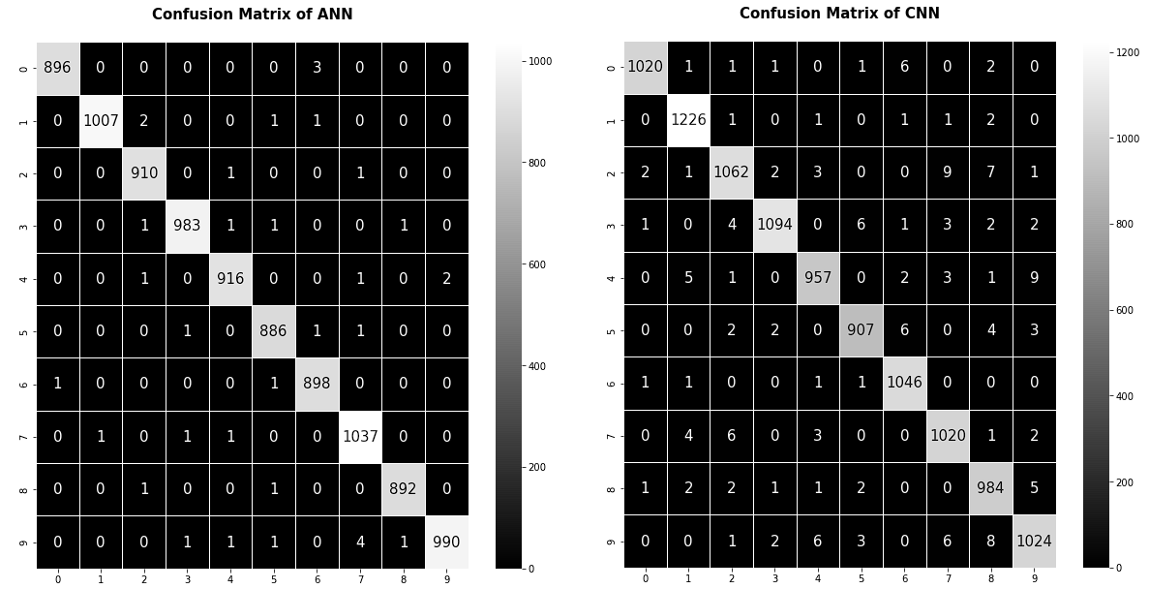
CONCLUSION
Recognizing handwritten digits is a common deep learning problem that is useful for students to learn as an introduction into deep learning methods and evaluation. ¹ The task is to scan pixel images of handwritten digits and identify them as a number between 0 – 9. The success of the digit-recognition deep learning model will be based on the accuracy of the digit predicted compared to its actual value. Current existing models have been able to achieve excellent results, with an accuracy prediction error of less than 1%. Accuracy and RMSE will be used to measure success. Supervised machine learning algorithms were chosen to perform the accuracy tests. They include support vector machines, k-nearest neighbor, convoluted neural networks and artificial neural networks. These algorithms were chosen due to its ability to classify different inputs successfully. SVM was predicted to do the worst out of the four and CNN or ANN was predicted to be the best at classifying the test dataset. ANN performed the best on the Kaggle test dataset, scoring at 97.53%. CNN and ANN were given specific functions implemented in their algorithm that would decrease the loss function and increase the accuracy of the model. As predicted, ANN and CNN both performed well at 97.6% and 96.5%, respectively. SVM had an accuracy of 91% and KNN had an accuracy of 96.3%. While it wasn’t unexpected, it was surprising how close the accuracy was between the models. Between ANN and SVM, there was only a difference of 6.6%. Since KNN is one of the simpler models, it was expected that KNN and SVM would perform similarly, but KNN had an accuracy that rivaled the neural networks. The neural networks also did not perform as well as expected, which was predicted to be close to 99% and above, but the best, ANN was 97.6%. This brings into question how complicated does an algorithm need to be to be effective? This will be a question that can be answered on a situational basis and tested every time.

References
- Brownless, Jason. Handwritten Digit Recognition using Convolutional Neural Networks in Python with Keras. Machine Learning Mastery. Published June 27, 2016. https://machinelearningmastery.com/handwritten-digit-recognition-using-convolutional-neural-networks-python-keras/
- Kaggle Digit Recognizer. Learn computer vision fundamentals with the famous MNIST data. Kaggle. https://www.kaggle.com/c/digit-recognizer/overview/description
- Lecun, Yann, Cortes, Corinna, Burges, Christopher J.C. THE MNIST DATABASE of handwritten digits. http://yann.lecun.com/exdb/mnist/
- Ghandi, Rohith. Support Vector Machine — Introduction to Machine Learning Algorithms. Toward Data Science. Published: June 7, 2018. https://towardsdatascience.com/support-vector-machine-introduction-to-machine-learning-algorithms-934a444fca47
- Saha, Sumit. A Comprehensive Guide to Convolutional Neural Networks- the ELI5 Way. Toward Data Science. Published: Dec 15, 2018. https://towardsdatascience.com/a-comprehensive-guide-to-convolutional-neural-networks-the-eli5-way-3bd2b1164a53
- Joby, Amal. What is K-Nearest Neighbor? An ML algorithm to classify data. Learn Hub. Published: July 19, 2021. https://learn.g2.com/k-nearest-neighbor
- Deepanshi. Beginner’s Guide to Artificial Neural Network. Analytics Vidhya. Published: May 25, 2021. https://www.analyticsvidhya.com/blog/2021/05/beginners-guide-to-artificial-neural-network/
- Technologies, S. (2017, December 20). Different Kinds of Convolutional Filters. Www.saama.com. https://www.saama.com/different-kinds-convolutional-filters/
- Brownlee, Jason. “How to Develop a CNN for MNIST Handwritten Digit Classification.” Machine Learning Mastery, 7 May 2019, machinelearningmastery.com/how-to-develop-a-convolutional-neural-network-from-scratch-for-mnist-handwritten-digit-classification/.
- Ali, Amir. “Convlutional Neural Network(CNN).” Medium, 7 Dec. 2019, medium.com/machine-learning-researcher/convlutional-neural-network-cnn-2fc4faa7bb63.
- https://systweak1.vo.llnwd.net/content/wp/systweakblogsnew/uploads/2018/03/hidden-layers-in-network.gif

Team Contributions
Odyssey -33% CNN and KNN
Kerry – 33% SVM and KNN
Yash – 33% ANN and Gradient Descent Back Propogation

Ancillary
Kaggle Submission Screenshots
